Barns And Noses, LLC 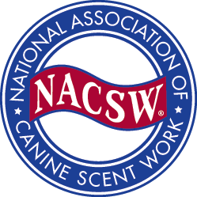

NACSW™ – Odor Recognition Test

Saturday, February 26, 2022
Kirtland Community Center, 7900 Euclid Chardon Road, Kirtland, Ohio, 44094
Registration Fee is $35.00 per odor, Payment by check only

Please mail this completed form via USPS with your registration fee to:
Janice Lipscomb
7871 Chillicothe Road
Mentor, OH 44060

Questions: Contact: Beth Mann, info@barnsandnoses.com

Odor: □ Birch □ Anise □ Clove

Test date(s): Saturday, February 26, 2022

Dog’s Call Name _____________________________________________________

Breed(s) ______________________

Dog’s NACSW #________________

Handler’s Name _____________________________________________________

Handler’s NACSW Membership # ____________________________________

Address _______________________________________________________

City __________________ State _________ Zip________

Phone where you can easily be reached __________________________
E-mail Address _____________________________________________________

An ORT must be taken and passed at least 14 days before a trial opening date to be eligible for the first draw period.

Please contact your host at least 1 day before the ORT if your female dog will be in season.

All confirmations will be sent via e-mail with attachment within 7 days of receipt of complete registration form and payment. If you require a confirmation via USPS, you must provide a self-addressed stamped envelope.

I/We hereby assume all risks of, and responsibility for, accidents and/or damage to myself or to my property or to others, resulting from the actions of my dog. I/We expressly agree that Beth Mann, Barns And Noses, Kirtland Community Center, 7900 Euclid Chardon Road, Kirtland, Ohio, 44094 and/or NACSW or any other person, or persons, of said groups, shall not be held liable personally, or collectively, under any circumstances, for injury, and/or damage to my person, for loss or injury to my property, whether due to uncontrolled dogs or negligence of any member of said groups, or any other cause, or causes.

Signed: ___________________________________Date: ______________________

